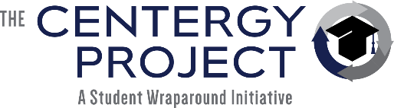
2022 Consulting Services
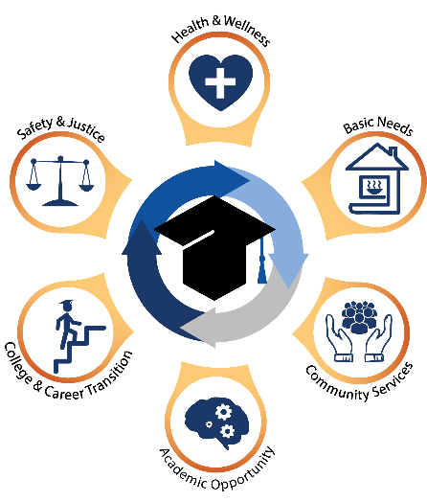

Consulting Services

The Centergy Project (TCP) provides training and support to school districts on the actionable processes to launch embedded wraparound services to address academic and non-academic barriers to student achievement. TCP consulting enables school districts to create “right-sized” systems of support that are tailored to the needs and resources of your district and community.

Our mission is to make equity actionable by assisting schools to ensure all students have equitable access to resources, services and opportunity.

TCP’s Wraparound
Services Model
The Centergy Cycle©
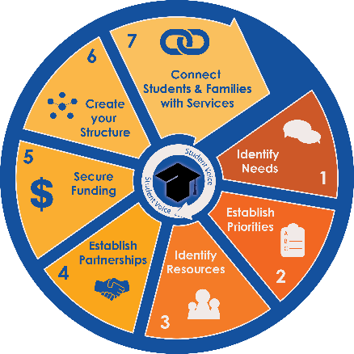
TCP’s process The Centergy Cycle© identifies and prioritizes needs through a framework of trust: gathering student voice, strengthening relationships, and cultivating hope. TCP guides schools and districts in gathering voice, analyzing data, asset mapping their communities, and coordinating services to align resources, partners, and funding.
The Centergy Cycle© is flexible, replicable, and scalable. For example, a school may decide to begin with some low-risk partnerships such as care closets and gradually grow the number of services offered over time. Alternatively, a school or district may have the capacity and resources for a full-scale, multiple partner implementation. By connecting students and families with embedded partner organizations and integrated student supports, schools grow collective professional capacity, create a supportive learning environment, and improve family and student engagement.
The recommended time span for launching a wraparound center is eighteen months to two years, broken down into two tiers (or years based on start date). Tier 1 focuses on laying the foundation: gathering student voice, developing staff capacity, and planning partnerships. Tier 2 targets tasks related to implementation: launching partnerships and building the structure to deliver services to students and families.

 | Centergy Cycle Processes | # of Days | Training and Deliverables | Participants
Tier 1  May be contracted individually or as a series of services | Gathering Student Voice | 2 days on-site  1 day of remote coaching during implementation | Student Conversation Circles and customized Online Survey to gather qualitative and quantitative data regarding student and family needs | Middle and High School Students and adult observers
 | Student Voice Training | 2 days on-site  1 day of remote coaching during implementation | Training focused on growing professional capacity for sustainability related to Whole Child, Wraparound Services, and the five TCP processes for gathering student voice:  - Conversation Circles  - Legacy/Graduation Stories  - Off-Track Interviews  - Needs Assessment  - Focused Conversations | Student Support Staff such as counselors, social workers, administrators, interventionists
 | Barrier-Specific Dig | 2 days on-site  1 day of remote coaching during implementation | Take a deep-dive into an identified barrier (i.e., substance use, stress & anxiety, etc.). This is done by gathering student voice, analyzing relative data, and developing a menu of full-spectrum services. | Middle and High School Students and identified staff
Tier 2  May be contracted individually or as a series of services  after the gathering of student voice | Centergy Cycle Training—  7 Steps to creating a  Whole Child School of Hope | 2 days on-site  1 day of remote coaching during launch of implementation | Training focused on The Centergy Cycle - a flexible, replicable, and scalable framework for bringing wraparound services into your school. (See Centergy Cycle image on page 1) | District/School level leaders, Student Support Staff such as counselors, social workers, interventionists
 | Partnership Development  Establish Priorities & Identify Resources | 2 days on-site  1 day of remote coaching during implementation | Analyze survey results, discipline,  and attendance data  Identify opportunities for  partnerships and services  Facilitate Community Strategic  Planning Meeting  Develop timeline for roll-out | District/School level leaders, Student Support Staff such as counselors, social workers, interventionists plus community leaders
 |  | Remote collaboration on colors and other customization | Create school/district-branding  TCP graphic palette customized with district/school colors, language, and logos for presentations and branding | n/a
 | Wraparound Launch  Launch and implementation of Wraparound Services Model | 4 days on site  4 days of coaching | Working with District-identified Wraparound Specialist(s) to create structure, embed partnerships, and connect families and students to services | Coordinator of wraparound services plus relevant Student Support Staff and Leader

For more information, contact Leigh Colburn at leigh@thecentergyproject.com.
For resources related to wraparound services, visit www.thecentergyproject.com.

